Action Bladder Cancer UK   
6 Trull Farm Buildings  
Tetbury GL8 8SQ

28.03.2025

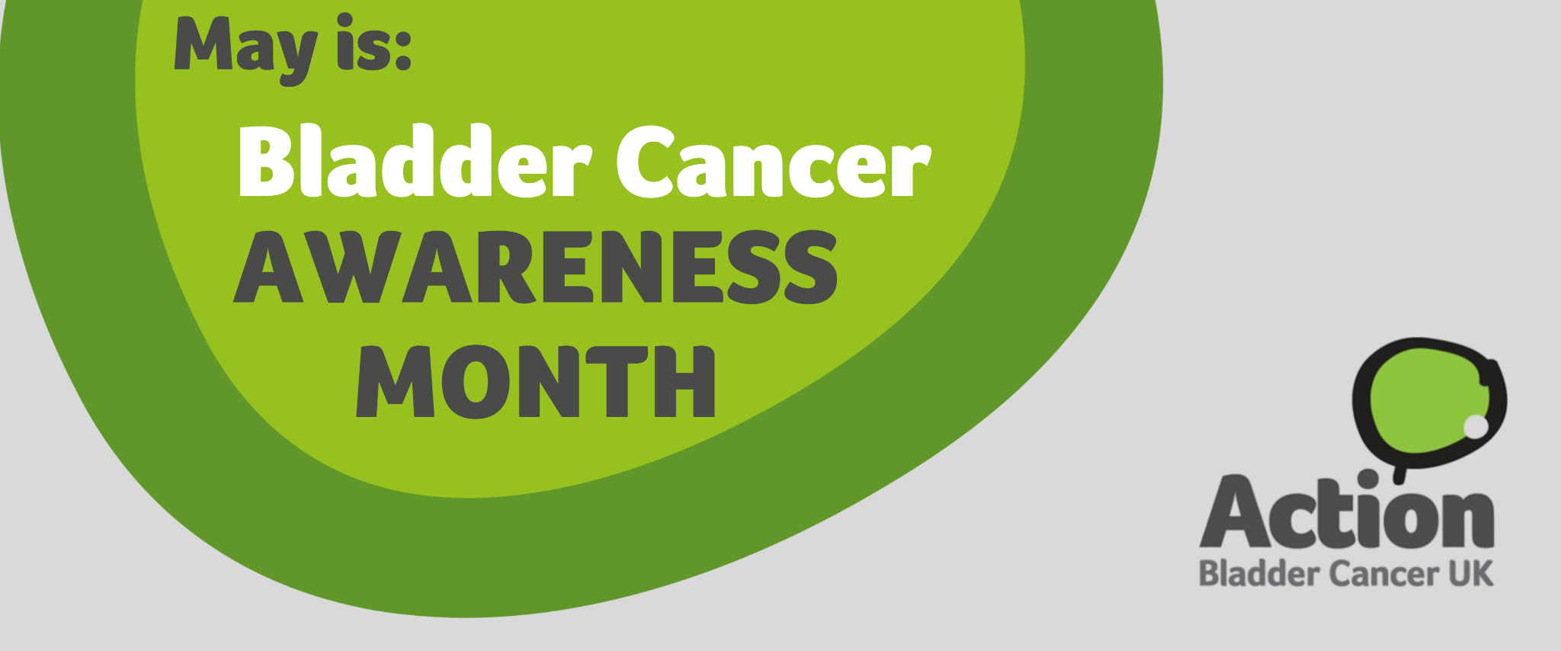

**Action Bladder Cancer UK urges GPs to learn about bladder cancer and help us raise awareness of symptoms in Bladder Cancer Awareness Month**

Action Bladder Cancer UK is calling on General Practitioners (GPs) to help raise awareness of bladder cancer during May’s Bladder Cancer Awareness Month by learning more about the symptoms and recognising the early signs of the disease.

In the UK, over 20,000 people are diagnosed with bladder cancer each year, yet it remains under-recognised as a common cancer and can often be diagnosed late. Key symptoms include blood in the urine (even if it occurs only once); the persistent or recurrent need to pass urine more often or more urgently; and discomfort or pain in the pelvic area. Action Bladder Cancer UK is urging GPs to familiarise themselves with these symptoms so they can diagnose bladder cancer sooner, ultimately improving patient outcomes.

By understanding and identifying the signs of bladder cancer, GPs can make a significant difference. Early referral to specialist care can lead to better management and treatment of the disease. We encourage GPs to [sign up for our learning module](https://actionbladdercanceruk.org/primary-care-education/) to learn more about bladder cancer, its symptoms, and best practice and to [visit our website](https://actionbladdercanceruk.org/) to find useful information and resources.

Action Bladder Cancer UK provides a wide range of free resources to enhance GPs knowledge and spread awareness, including printed materials, social media assets, and educational tools that can be shared with patients or used in practice. These materials aim to help both healthcare professionals and the public better understand the symptoms of bladder cancer.

Jeannie Rigby, CEO of Action Bladder Cancer UK, says: “Recognising the symptoms of bladder cancer early is essential for ensuring patients get the right care quickly. Unfortunately, bladder cancer can often be diagnosed only at a later stage, and can sometimes be overlooked, particularly in women, where symptoms can often be mistaken for urinary tract infections or gynaecological issues. GPs can help drive improved outcomes for bladder cancer by being alert to these signs and encouraging patients to seek medical advice if they experience any concerning symptoms, particularly blood in their urine”

For further information on ABC UK’s [Primary Care Learning Programme](https://actionbladdercanceruk.org/primary-care-education/), how you can [get involved](https://actionbladdercanceruk.org/get-involved/) in Bladder Cancer Awareness Month and support ABC UK, [order your resources and merchandise](https://actionbladdercanceruk.org/order-materials/) or download shareable [social media assets](https://actionbladdercanceruk.org/awareness-month/), visit the website or email [info@actionbladdercanceruk.org](mailto:info@bladdercanceruk.org).

For more information about Action Bladder Cancer UK and our work visit [www.actionbladdercanceruk.org](http://www.actionbladdercanceruk.org).

--------------------------------------------------- ENDS-----------------------------------------------

About Action Bladder Cancer UK:

ABC UK’s mission is to support bladder cancer patients and their families, raise awareness of the disease to improve early diagnosis and outcomes, and support research into bladder cancer.

**For media inquiries, please contact:**

Press enquiries -

E: info@actionbladdercanceruk.org

T: 0300 302 0085

W: www.actionbladdercanceruk.org

Registered charity: 1164374